DESERT EMPIRE AREA LEARNING DAY

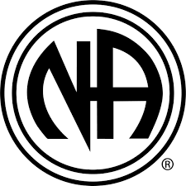

**July 19th, 2025 – 11am -1pm.**

1301 E. Mt. View, Barstow, Ca. 92311 Sheperd of the Desert Church

**Learning Day:** Area concerns and inventory.

Come to discuss your thoughts and ideas and have some ice cream and fellowship

