DEA 38th Spring Fling of

DEA 38th Spring Fling of NA on April 26th, 2025 from 11am-4pm at “K” st. Park

Food, 5$ donation, from 11am- 1pm. Speaker at 1pm -2:30pm Bouncy house for kids.

Water and Soda, $1.50 – bring a chair.

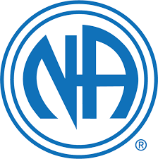

For more information call Tim 760 559 2461n or Billy 442-867-8444

There will be hamburgers and hotdogs, please bring a side for the picnic potluck.

Food, Fun, Fellowship

|  |
| --- |
|  |
|  |
|  |
|  |