**Where?** 1301 East Mt. View, Barstow Ca.92311, Shepard of the Desert Lutheran Church

**What?** Come learn about how groups and the area are run and to carry a clear NA message.

**Who?** This event is put on by the Desert Empire Area’s steering committee and is meant for DEA members in service especially. And for those who would like to be of service.

We will have special **speakers** with many years of experience in NA service. There will be a Q & A

**Lunch** will be provided, but please bring a dessert or salad if you can. Thank you.

 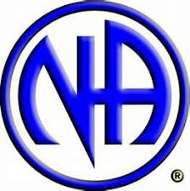 

DEASC PRESENTS

LEARNING DAY

